**Artificial Intelligence (AI) on AWS Cloud!!!**

**✨ WHY??????**

**According to a recent report by the International Data Corporation (IDC), global spending on AI solutions is set to hit a whopping $77.6 billion by 2022; the same study also predicts that AI and ML could unlock an additional $2.6 trillion to the value of Marketing and Sales, and no less than $2 trillion in the manufacturing and supply chain planning industries.**

**✨ What I learnt???**

* **Amazon Comprehend** : Advanced text Analytics (Use natural language processing to extract insights & relationships from unstructured texts
* **Amazon CodeGuru** : Automated code reviews (Automate code reviews & identify your most expensive lines of code
* **Amazon Lex** : ChatBots (Easily build conversational agents to improve customer service & increase contact center efficiency
* **Amazon Forecast** : Demand forecasting (Build accurate forecasting models on the same machine learning forecasting technology used by Amazon.com)
* **Amazon Textract** : Document analysis (Automatically extract text and data from millions of documents in just hours, reducing manual efforts)
* **Amazon Kendra** : Enterprise search (Add natural language search capabilities to your apps so users can find the information they need more easily)
* **Amazon Fraud Detector** : Fraud prevention (Identify potentially fraudulent online activities based on the same technology used at Amazon.com)
* **Amazon Rekognition** : Image and video analysis (Add image and video analysis to your applications to catalog assets, automate media workflows, and extract meaning)
* **Amazon Personalize** : Personalized recommendations (Personalize experiences for your customers using machine learning technology perfected from years of use on Amazon.com)
* **Amazon Translate** : Real-time translation (Expand your reach through efficient and cost-effective translation to reach audiences in multiple languages)
* **Amazon Polly** : Text to speech (Turn text into life-like speech to give voice to your applications)
* **Amazon Transcribe** : Transcription (Easily add high-quality speech-to-text capabilities to your applications and workflows)

**😇My work😇**

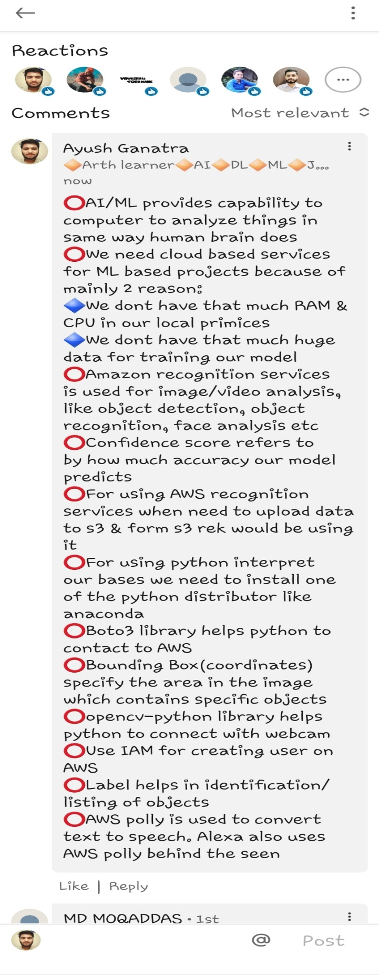

**😇My work😇**

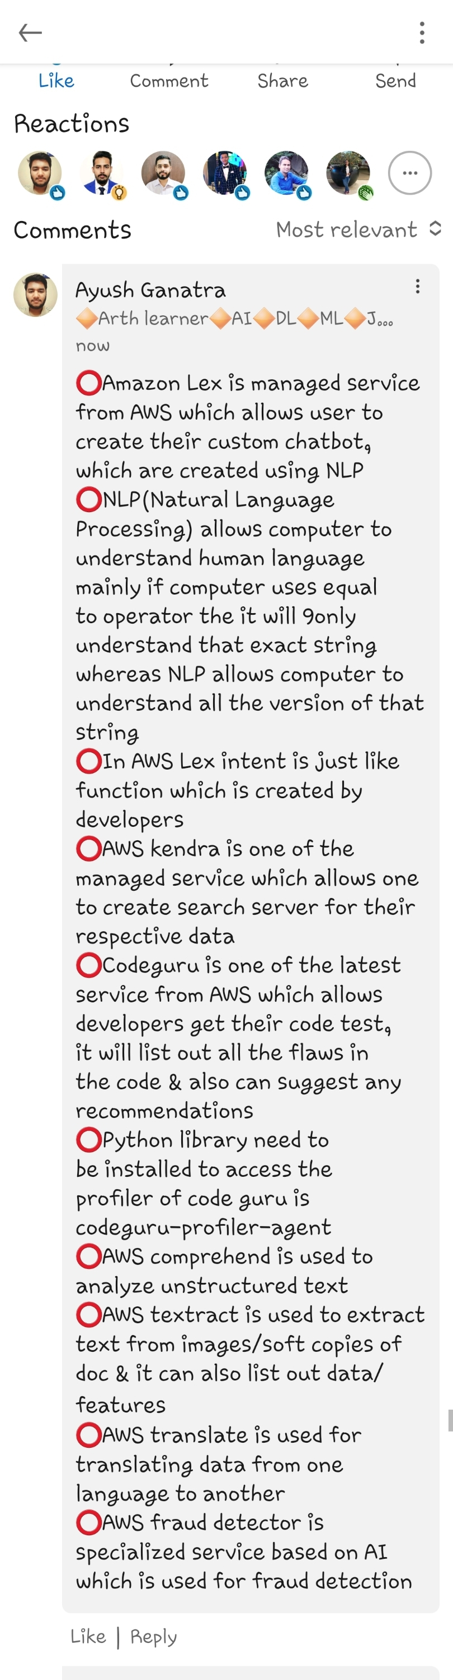

**😇Glimps of small integration of AWS Polly & AWS Rekognition using python SDK(boto3)😇**

